**ASSIGNMENT 24.4**

* **Using database:-**

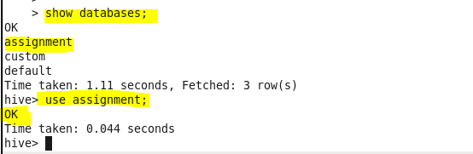

* **Creating table:-**

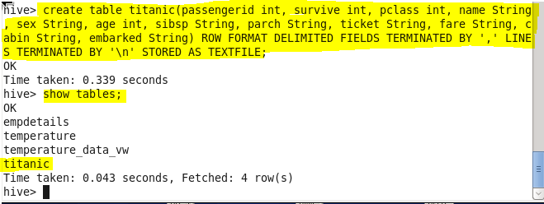

* **Loading data from data file:-**

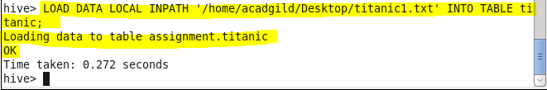

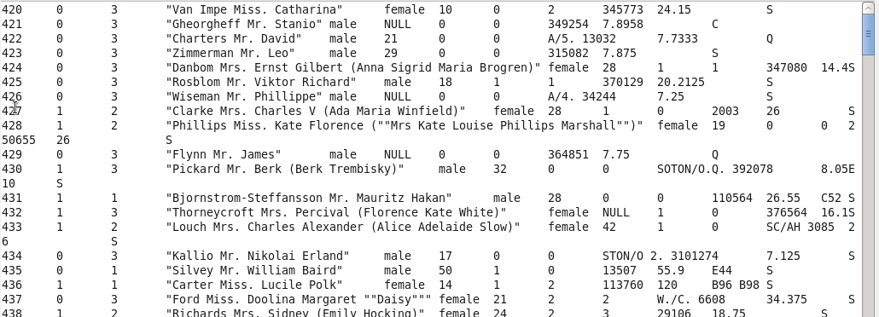

* **Write a hive query find the average age of male and female persons died in the titanic tragedy**

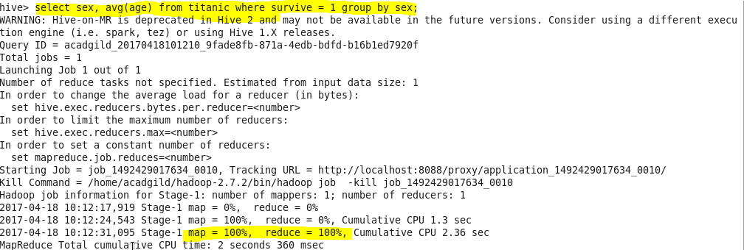

**Output:**

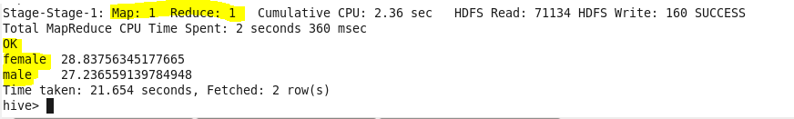

* **Write a hive query to find the number of people died and survived in each class?**

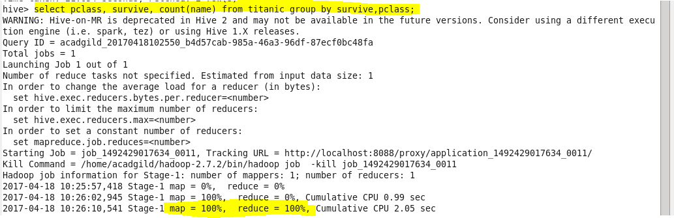

**Output:-**

